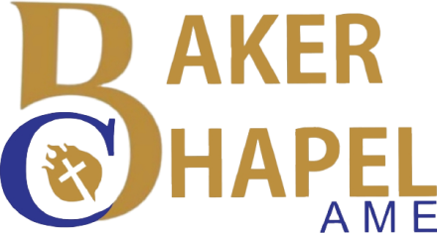
African Methodist Episcopal Church
10th Episcopal District
2022 Northwest Texas Annual Conference

Digital Souvenir Journal Advertisement Form
139th - 19th Session – Northwest Texas Annual Conference
Submission Deadline – August 31, 2022
Submitter Name: ________________________________________________________

Telephone#: ____________________________________________________________

Email Address: __________________________________________________________
Name of Church/Organization:
The Digital Souvenir Journal will be presented in digital format during the Annual Conference. Format submission options: Self-prepared standard picture type ads in the following formats: pdf, jpeg, png, or word format. Prerecorded video ads in the following format: MP4. (30 seconds maximum

A Journal submission form must be completed for EACH INDIVIDUAL AD. Only one ad per form.

Due Date August 31, 2022

Submission of the ad will be by email only: -Complete the form and include it with ad submission when emailing. Payments are due upon submission of the ad and form. No ads will be accepted without a form, confirmed online payment, or digital file. Email form to: churchoffice@bakerchapelame.com. Online payment options are listed below.
Ad Format | Description | Select One | Price
Prerecorded Video | 30 Second duration |  | $200.00
Prerecorded Video | 15 Second duration |  | $100.00
Slide | 10 sections duration |  | $75.00
Slide | 5 second duration |  | $50.00
Patron | Slide with list of Patrons |  | $25.00
Notes: Self-prepared still ads and prerecorded videos are created by the submitter with standard verbiage for best wishes, congrats, business/company support, etc. The video should be recorded in landscape positioning. Slides can be in portrait or landscape positions.

Total Ad Payment: ___________________
Online Payment: Please use the section below to identify the payment purpose for the Annual Conference advertisement
Check one used: $Baker Chapel-Cash App____ Baker Chapel-Givelify____ Baker Chapel-PayPal ____
The Credit Card payment option is available via the Baker Chapel AMEC website donation page. Use this link: www.bakerchapelamechurch.org/donate.
For more information or questions please contact Rev. Patricia Preston at 817-336-5326 or churchoffice@bakerchapelame.com

Rev. Dr. Melvin D. Wilson, Jr., Senior Pastor
1050 E. Humbolt St., Fort Worth, TX 76104

